TUESDAY SEPTEMBER 26th
GAINESVILLE
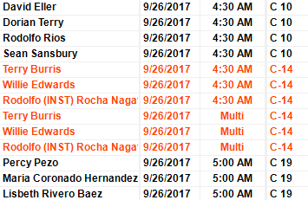
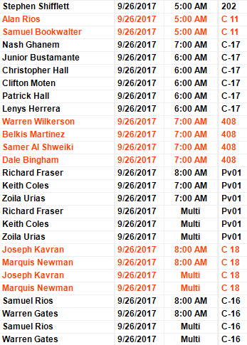
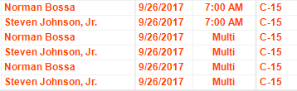
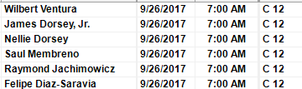

Manassas
Carlos Collantes 7:00am 207

