**Monday October 1st**

**Manassas 6 AM**



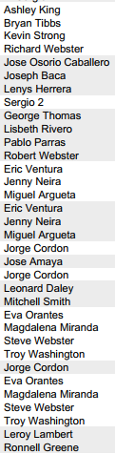

**Manassas 6 AM**

